NEWSLETTER SUMMER 2020
Don’t forget !
You can keep up to date with things going on at the church through our website
www.swanseastmary.co.uk
or on facebook ; St Mary’s Swansea
or on Twitter : @stmaryswansea
email : stmarysswansea@gmail.com

Dear Friend

I’m not quite sure we’re due another newsletter yet, but time seems to be working differently this year and so I thought it would be a good idea just to bring you up to date with what’s been happening. As you will probably know church buildings remain closed in Wales. We’re not sure for how much longer but when we are given permission to reopen we will need to ensure that all the appropriate safety measures are in place to do so to protect those coming in to pray and the volunteers. It’s a daunting task in some ways but one which we must do so as to offer a place of peace and sanctuary right in the heart of the city as shops begin to open. We are also shortly to begin our breakfast club for people who are homeless or looking for some company. It will be differently, mainly because it will now be a takeaway Brunch club ! We are working closely with some other churches and the local Council to ensure what we are providing is the most useful thing to provide and this is the answer at the moment. Please pray for wisdom and safety as the church building begins to reopen.

Of course, that doesn’t mean that the Church hasn’t been operating over the last 3 months. In very different ways we have been trying to keep in touch with people, caring for them, supporting those in most need, comforting those who are suffering for whatever reason and praying for the needs of the church and the world. The clergy team have been meeting twice a week for Morning Prayer online by zoom and have kept closely in touch. There is a zoom bible study group and we’ve held a zoom prayer meeting. We’ve done some online projects involving lots of people from the Parish and I’ve included some YouTube links for those of you who are able to access a computer. These have all been in addition to providing services on a Sunday as well as a short service on a Wednesday each week.

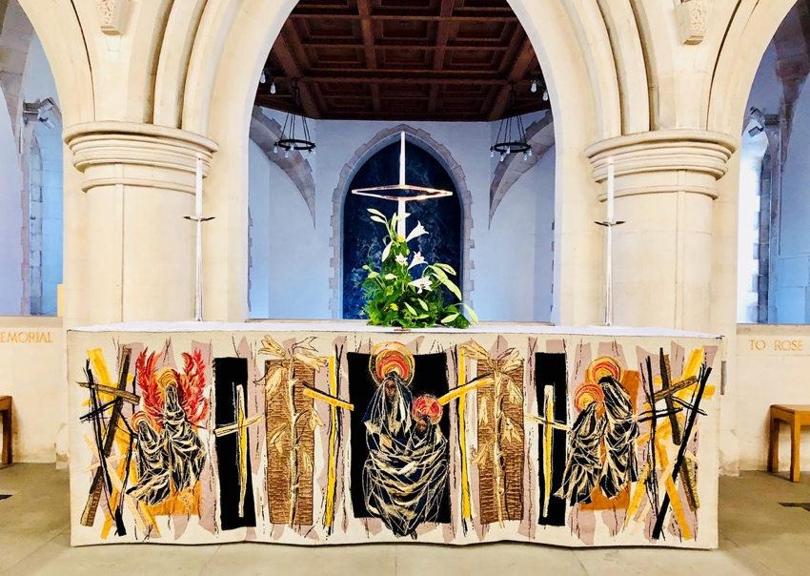
Holy Week was nothing like the usual programme of course, but we did manage to do special services online for Maundy Thursday, Good Friday and Holy Saturday as well as Easter Day and we were reminded through that time that even out of the greatest times of darkness, light always wins in the end. Even as we go through these unusual times, we can be assured that God remains with us and light will always shine through any darkness. As well as all of the clergy taking part in the services, we have had organ music from Dr William Reynolds and singing from his family which has been a real blessing. Although people could not get in the church to see it we were able to have the Altar decorated for Easter as you can see from the picture and let people see that the building, whilst closed for public worship, still represented a special place at such an important time of the year.

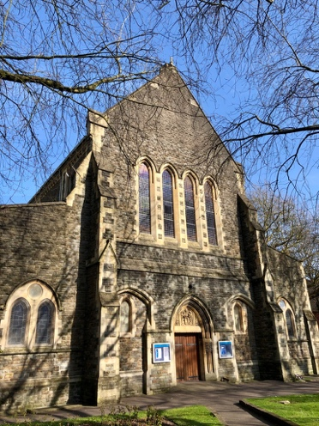
Of course, there are lots of people who are not able to access a computer so there have been a good number of telephone calls and we have also sent out 2 Daily Prayer booklets for people to use at home. The first included some of Lent, Holy Week and the Easter season and the most recent covered the period from Pentecost onwards. We’ve been really pleased to receive some good feedback about the various things that have been done and whilst none of it is the same as meeting together, it hopefully helps in the current circumstances.

I hope this has given some insight into what’s been going on and I’ve copied a few links to various projects we’ve done through this time for those of you who have access to a computer. We also have YouTube page for St Mary’s which can be found under St Mary’s Swansea. All of these projects are on there along with the weekly services. If you subscribe (it doesn’t cost anything) you will get notifications whenever anything new appears on there. We also have an email list sand emails are ent out twice a week giving details of services and occasionally other news. If you’re not on the list and would like to be please let us know.

It’s been a strange time but a time when lots of people have done special projects. One of those is Paul Murray who has been doing more work on the history of St Mary’s and over the next few pages there’s an article which he has put together which I hope you find interesting.

Every blessing,
Ian Rees (Rector of Central Swansea)

If you feel able to help financially then please consider making a bank transfer to St Mary’s Swansea, HSBC Account number 61705970, Sort code 40-43-31 or send a cheque for St Mary’s Swansea to 50 St Catherine’s Court, Swansea, SA1 1SD.
Standing order forms are also available if you wish to contribute on a regular basis.
We also have a Crowdfunder page running until the end of June where donations online can be made very easily. The link for this is : https://www.crowdfunder.co.uk/asking-people-to-help

If you’re not able to do this at this time then please still be assured of our huge thanks for the support you do give to the church and your interest in what is going on here and again, can I ask you to please remember to encourage others you may know to think about becoming a Friend of St Mary’s. Forms are available from church (please email stmarysswansea@gmail.com for a form or if you have any questions at any time) . With best wishes and thanks again for your support.

YouTube Links

Psalm 23 : https://youtu.be/Em8qjtq9DCk

The Lords Prayer : https://youtu.be/KxKsjeN1gTc

Living in the present and looking forward to the future : https://youtu.be/VdoDjgC0KlY

Civilian Roll of Honour at St Mary’s Church, Swansea

Sunday 21st February 2021 will be the 80th Anniversary of the destruction of St Mary’s Church by enemy action during the 2nd World War.

Swansea endured 44 air raids between June 1940 and February 1943 and although only a few of these caused much damage six were of the ‘Blitz’ type air attacks. On the 19th, 20th and 21st of February 1941, known as the “Three Night Blitz”, a combination of parachute flares, High Explosive Bombs and Incendiary Bombs were dropped which saw the town centre almost completely destroyed, 230 people killed and a further 409 injured. It was of course the third night, the 21st when St Mary’s was almost totally destroyed and like the market alongside it gutted by fire. In total during the 44 air raids on Swansea some 387 civilians were killed and over 850 injured.

On the second night of the three night blitz, 20th February 1941, John Ernest Murray Bishop aged 26 years of the Home Guard died at Teilo Crescent, Mayhill along with 23 others. He was the son of George William and Minnie Ada (nee Murray) Bishop, a cousin of mine. He was buried in a new grave at Oystermouth Cemetery where today he rests with his parents who died in 1965 and 1966 respectively. The headstone reads “Died through Enemy Action”

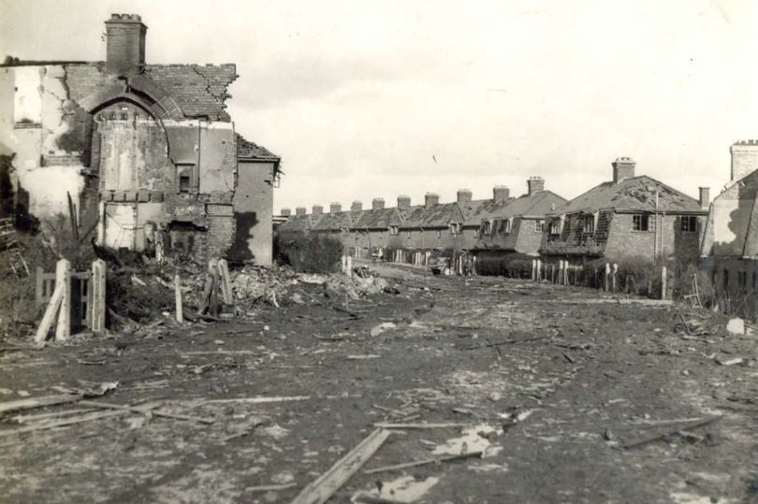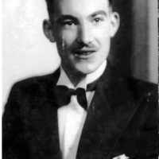
Teilo Crescent, Mayhill after the bombing on 20th February 1941 and ‘Ernest Bishop’

The Holy Trinity Chapel at St Mary’s Church was built to commemorate the Holy Trinity Church in Alexandra Rd, which had also been destroyed in the war. It was to a design by Sir Percy Thomas the church architect and in its west wall is a specially prepared niche built to house the Borough of Swansea Civilian Roll of Honour for those 387 civilians who died in Swansea during the war. The beautifully bound red leather book contains a list of their names, in alphabetical order, their age, family members and place and date of their death and occupation where appropriate. The book is housed in an oak, bronze and glass case which was made by Messrs Percy Symonds of Swansea and both the book and case were provided by the Swansea Corporation.

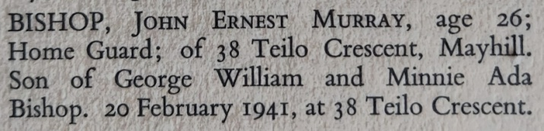
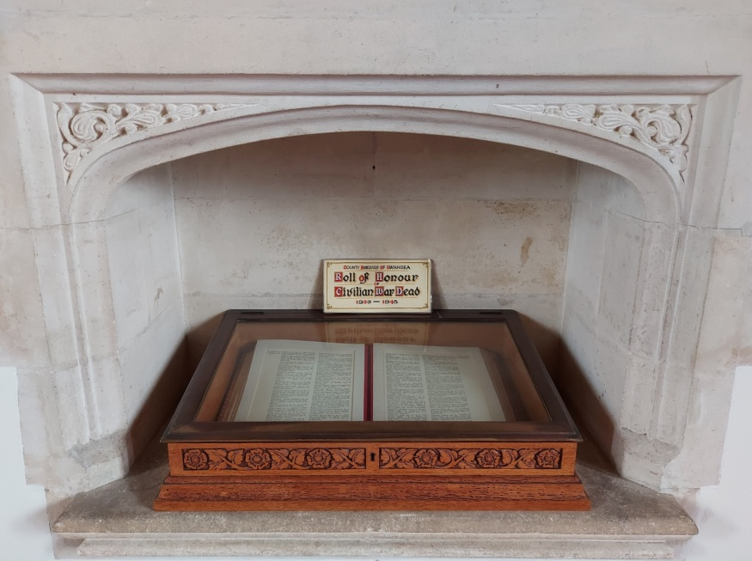
The Swansea Civilian Roll of Honour at St. Mary’s Church

But the story does not end there. This book is only an exert of the National Civilian Roll of Honour which is housed at Westminster Abbey on the south side of the Great West Door near to the tomb of the unknown soldier. There are eight volumes held in their case, geographically arranged, with each one displayed in rotation and the pages turned regularly.

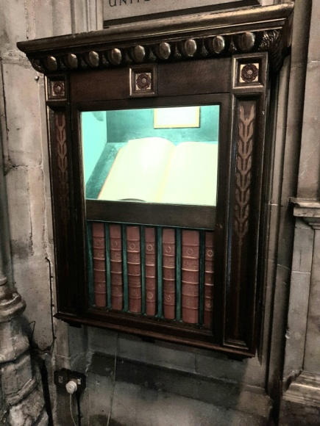
The National Civilian Roll of Honour at Westminster Abbey

I’m sure that the parents of John Ernest Murray Bishop would have been proud to know that their son’s name was commemorated at the Abbey along with the Kings and Queens of England, the Unknown Soldier and the names of Prime Minister’s, worthy politicians, scientists, musicians and poets recorded in that great place, but and I am sure they would have preferred that their son hadn’t been killed in the first place.

As it says in the introduction to the book at Westminster Abbey
“To a greater degree than ever before, the 1939-1945 War involved not merely armies but entire nations. The names of individuals mean little save to those who knew and loved them and mourned their loss, and the number that mourn will dwindle as years pass by. But it is fitting that these names should be enrolled in Westminster Abbey, at the heart of the Commonwealth and among the most illustrious of the Nation’s Dead, in commemoration of their suffering and as attribute to their sacrifice”

Paul Murray June 2020

